Condition in the Bleiswijk 1 Area and the Network topology:

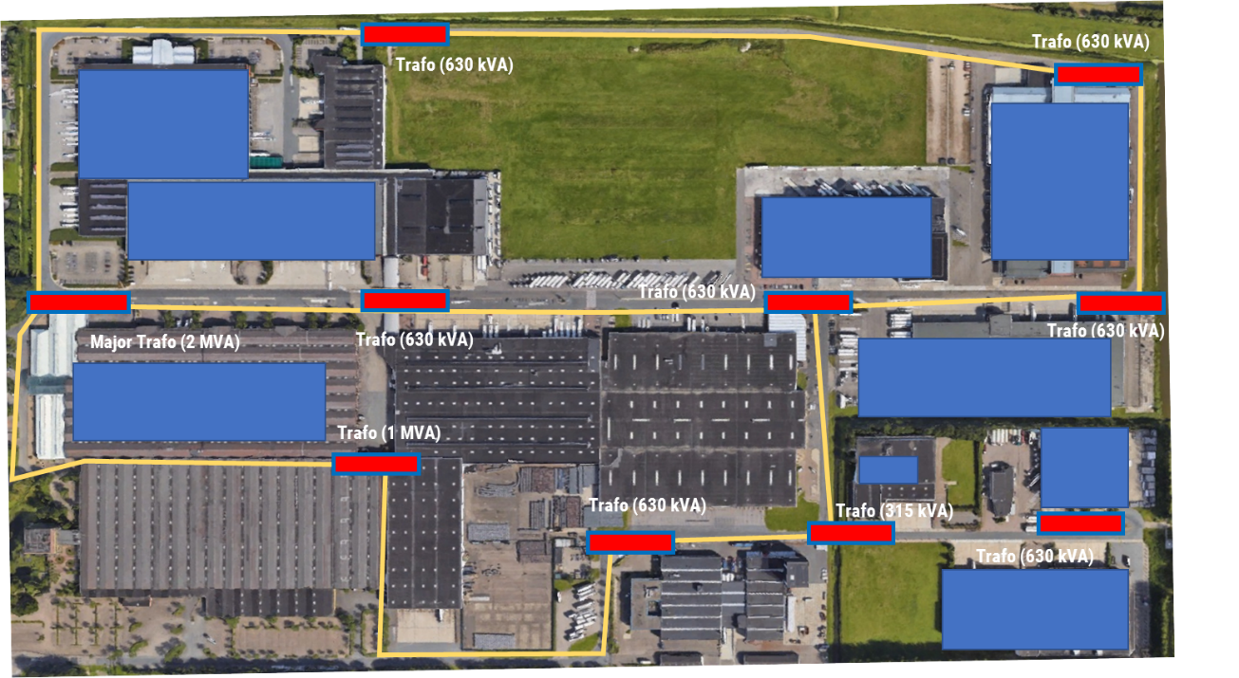

Current load condition of the Bleiswijk 1 Area:

The current power infrastructure in the Blesiwijk area 1 is still way under the capacity of the congestion. Total capacity of the Substation for Bleiswijk 1 is 4 MVA. However, the situation might change once Zalando is coming to the Bleiswijk 1 area. Between the observed timeline there are several extreme loads on July. These extreme loads are the results of STEDIN maintenance activities. As a result there is no significant load and congestion in the current demand situation.

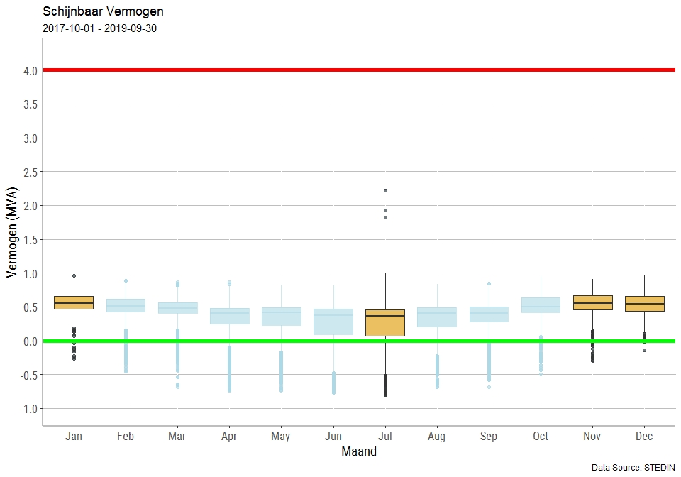

Here we see that the current load are distributed almost uniformly across the year except differences between the peak winter and summer time. As a note, July volatility of load is higher than the other months. This mainly due to the increasing production of renewable energy installed in Bleiswijk which predominantly comes from the Solar PV and the relatively lower energy consumption due to the vacation season. When we remove some extreme data out, we observe that the volatility effect on July is fairly limited yet still starkly different than the peak winter time. In addition, the daily load differs significantly between the working days and weekend days. On average the weekend load is 40.82% lower than the weekdays load.

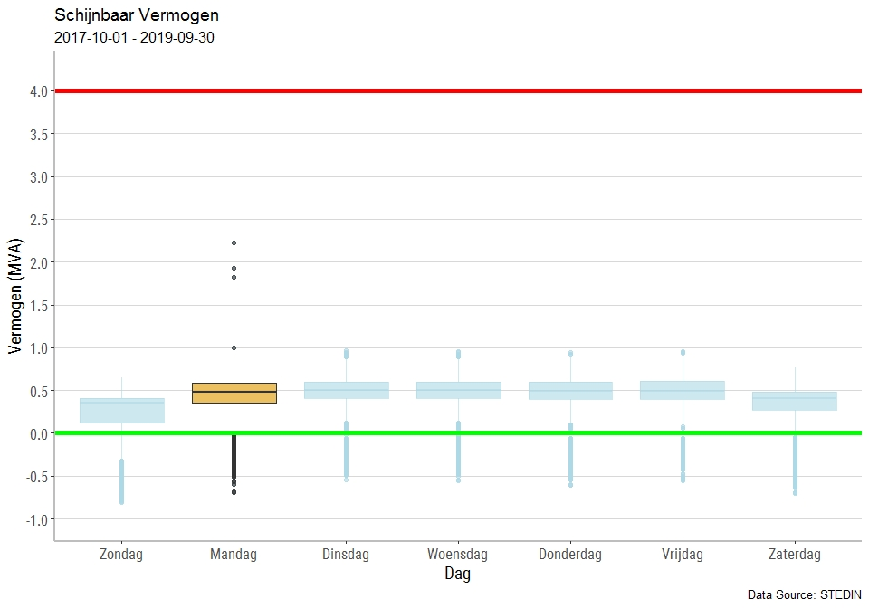

From the system perspective, there is high opportunity to conduct Flex due to the capacity available in the largest transformer. That translates into the individual company’s behavior. The following graphs shows the current tariff structure impact to the individual companies if they distributed the load uniformly across the Bleiswijk 1 ring. Based on the historical data, December and January are two months in which the load spikes more probably to incur.

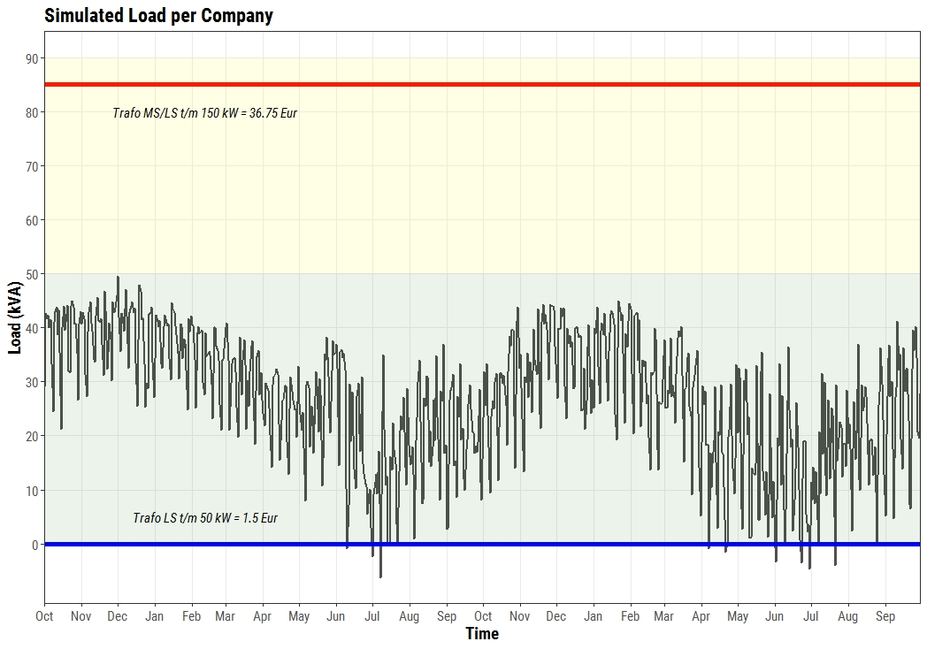

If we look at the individual company closely, the company significantly uses more energy from the grid on the winter times. Companies are often gets into the higher tariff bandwidth in December and January. Within these two months there are 65% higher chances that companies will surpass the 50kVA bandwidth. These happen due to decreasing number of electricity produced by the installed solar PV and increasing heat pump consumption.

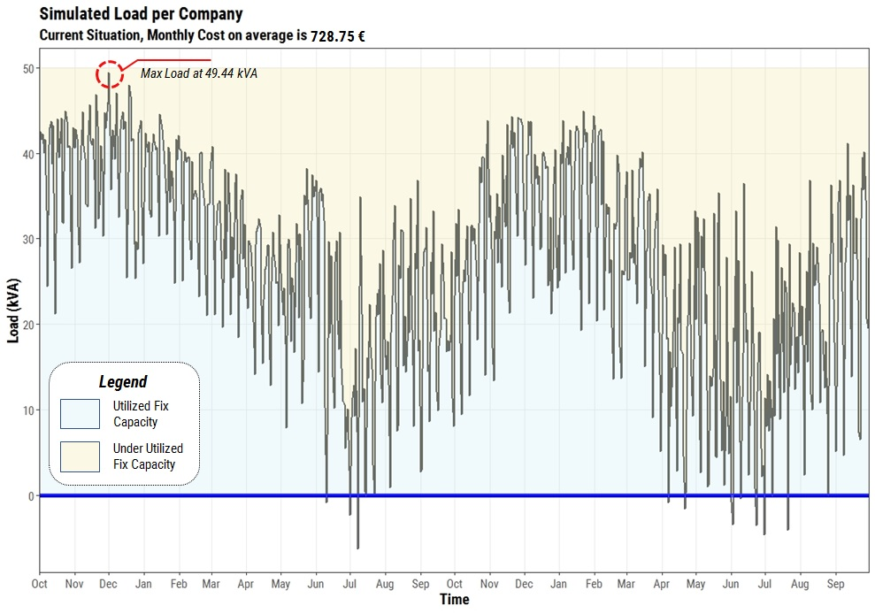

## Opportunity of Flex based on the Comparative tariff and the external market.

Looking at the amount of capacity available, the options to export electricity to external markets are becoming more attractive. At this moment we are looking at the APX and Tennet imbalance market as the benchmarks of export market. Both external markets offers different balancing mechanism to the local market. The Tennet imbalance market offers a more flexible interval with 15 minutes PTU while the APX EPEX Intraday market is offered hourly.

Looking at the distribution of APX daily data, the weekdays demand seems to be concentrated at Tuesday and Wednesday. System’s demand during these days significantly higher than the rest of the weekdays. It is also important to note that the average system’s demand are 15% less than the weekdays, making it quite unattractive to export the electricity during the weekends. Furthermore, we observe a seasonality pattern based on the monthly demand. On Summer the APX prices is considerably lower than the other months. This situation makes exporting electricity to the APX market unattractive.



Figure 1 Imbalance Market Profile Tennet (average from 1-1-2017 to 31-12-2018)



Figure 2 Imbalance Price Profile Tennet (average from 1-1-2017 to 31-12-2018)

